**T/E Corporate Cards** are meant to be reported and replaced if ever lost or stolen. It is the responsibility of the cardholder to take the following action.

1. The cardholder needs to call the US Bank 1-800 number on the back of their corporate card and report their card lost or stolen.
   1. They must also review their transaction history to ensure there are no fraudulent charges to report.
2. The cardholder must notify their supervisor and their department Financial Assistant/ Delegate that they have lost their corporate card and will be applying for a new one.
   1. The Financial Assistant/ Delegate will give them the appropriate account string to use when they are in Concur applying for their new corporate card.
   2. The mailing address may vary depending on what the staff's primary work location is.
3. The cardholder must apply for a new corporate card via Concur.
   1. Instructions can be found here - <https://ucsb.service-now.com/kb?id=kb_article_view&sys_kb_id=931330271bddcd10e9250f22604bcbb4>
4. Once the cardholder receives their new corporate card, they must:
   1. Activate it
   2. Inform their dept Financial Assistant/Delegate of the last 4 digits of the card.
5. Lastly, the cardholder must submit a ServiceNow Ticket to BFS and inform them of their new corporate card number.
   1. Link to Service Now is here - <https://ucsb.service-now.com/global>

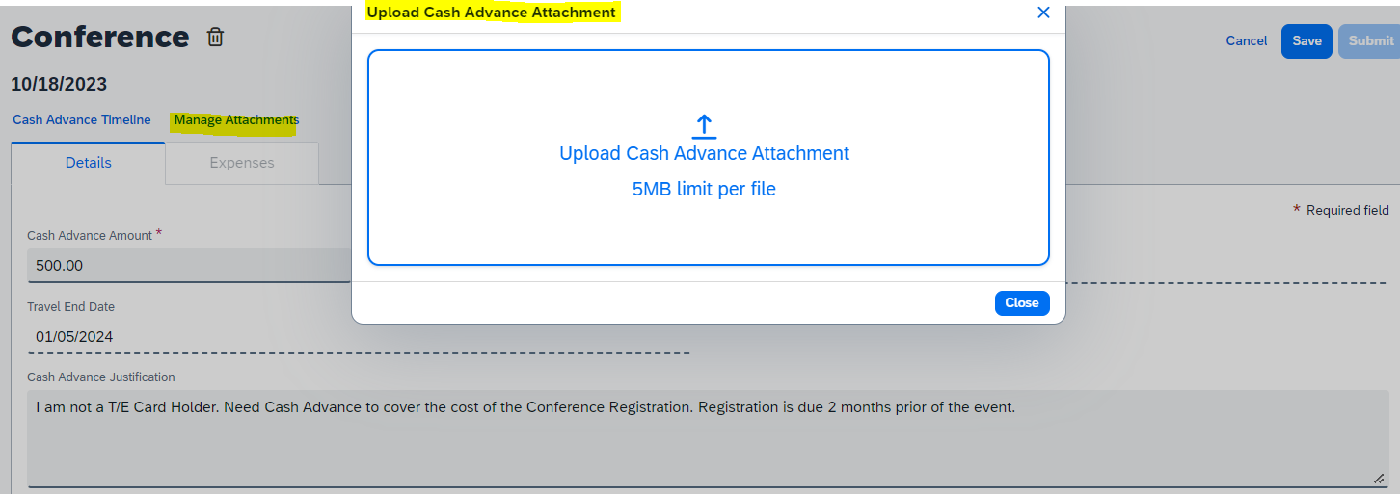

1. Once you’ve noted everything for your Cash Advance, Save it to your Request. The Cash Advance information should then be displayed in the Cash Advances section above the Expected Expenses list.

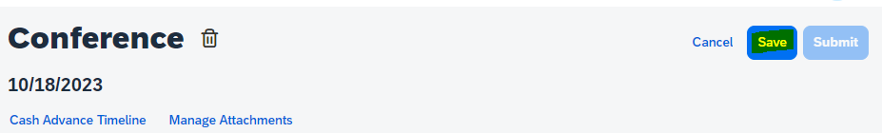

***

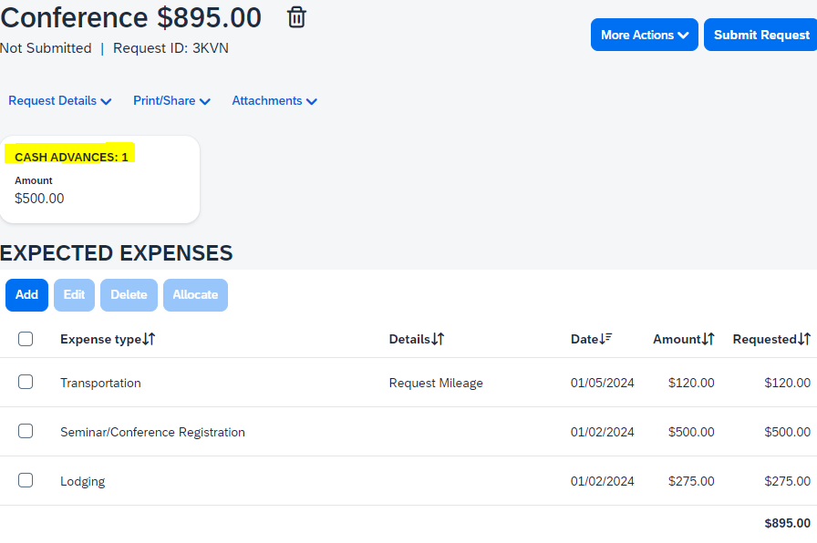

1. Once you confirm that you have your Cash Advance and all your Excepted Expenses listed, select Submit Request. Your Request and Cash Advance will enter its approval workflow. Once the Request has been approved, the cash advance will show its status on the Expense>Cash Advances> View Cash Advances page in Concur Expense.

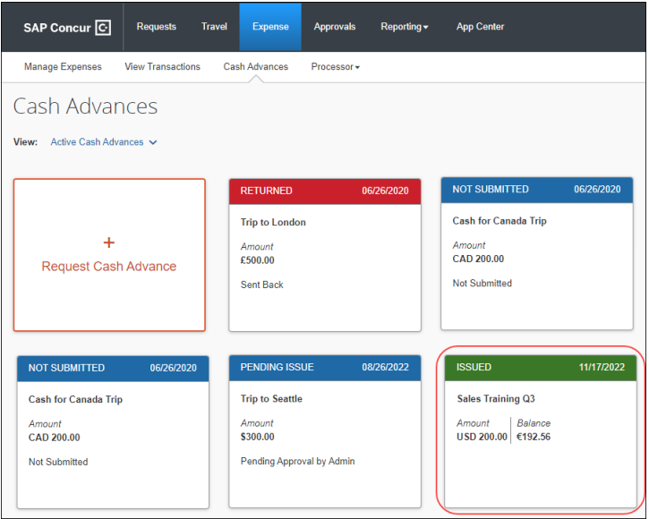

1. Once the request is submitted and approved, the Cash Advance will be issued the same way you receive your paycheck. It’s important to review what has been noted as Issued as soon as possible so that you may confirm you have received the funds. If not, connect with you Delegate to get the issues resolved.
2. Finally, once your event has passed, make sure to include the Cash Advance in your Final Expense Report. As you would your Card Transactions, please be sure to link all Cash Advances to the appropriate Concur Report at the time of submitting your Report for reimbursement/allocation.